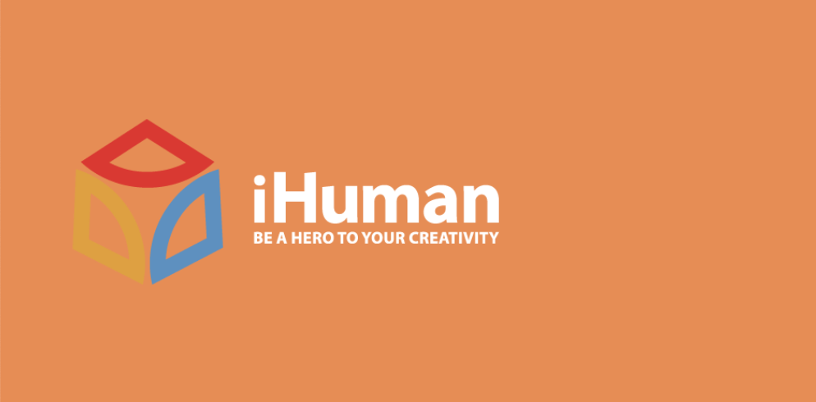
Mental Health and Addictions Counsellor
Job Opportunity

Who we are:
iHuman Youth Society is a non-profit organization whose mission is to serve marginalized youth; promoting their inclusion in the community through crisis intervention, arts, mentorship and life skills development programming.

iHuman embraces everyone. From cultivating a culture where all employees can bring their best selves to work to deploying diversity initiatives that support our youth, we’re doing what it takes to build a more equitable workplace and world.

What we can offer you:
After completing the probation period, we offer generous health and dental benefits and paid time off. The Mental Health and Addictions Counsellor will work in a creative work environment to impact vulnerable and marginalized youth positively. If you are a passionate Counsellor looking to work in a nontraditional way, we welcome your application.

About the Role:
An integral part of iHuman’s iSucceed division, the Counsellor works in the LiNKS program, which offers arts-focused programming grounded in trauma informed care and harm reduction principles. Program participants may be vulnerable and experiencing homelessness. LiNKS provides participants with access to mental health supports that strengthen their ability to cope with a variety of mental health disorders, emotional and relational disturbances, and adjustment problems. In addition, this position will provide traditional therapeutic services that support and protect the mental health of individuals aged 12-24 years while concurrently working to support the reduction of risk toward substance abuse and behavioral addictions.

This position works 37.5 hours/week from Monday to Friday, working primarily daytime hours. Occasional evenings and weekend hours may be required.

What you would do:
- Conduct assessment and intervention protocols that best address adolescent, emotional, behavioral and mental health and addiction concerns
- Facilitate the navigation of potentially complex systems to sustain community services that address the mental wellbeing of the participant
- Provide information about programs that will increase acceptance and understanding of mental health and promote wellness
- Ensure professional skills used to provide services and supports to participants reflect best practices by engaging in a process of continuous learning and professional development.
- Ensure services align with program outcomes by capturing results and celebrating achievements for each participant

Qualifications:
- Master’s Degree in Psychology, Social Work, Counseling or Therapy
- Additional coursework and experience in addiction counseling
- Minimum 3 years of experience working as a Counsellor, Social Worker, or Therapist supporting youth
- Registered with an applicable licensing body.
- Clear Police Security Check and Child Intervention Check (dated within 90 days)

Wage: $37-$39/hour

To Apply:
Please send a cover letter and resume in one document (Word doc or PDF) to the iHuman HR Consultant, at violet@ihuman.org. Please include “Mental Health and Addictions Counsellor” in the subject line of the email. The position will remain open until a suitable candidate is found.

We appreciate your interest. Only candidates selected for an interview will be contacted.

